**Pymaceuticals Report**

***Kaveh Amini***

In this study, 250 mice were treated through a variety of drug regimes over the course of 45 days. Their physiological responses were then monitored over the course of that time. The data have been analyzed both for all ten drugs and also with a focus on Capomulin, Infubinol, Ketapril, and Placebo and how they compare.

Fig 1. The Tumor response to the all drugs studied

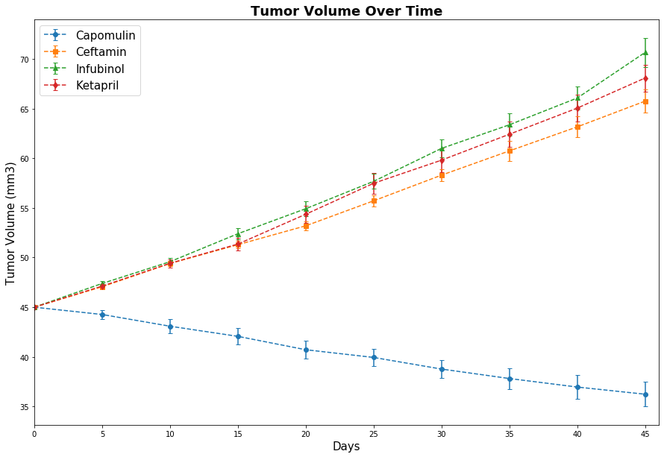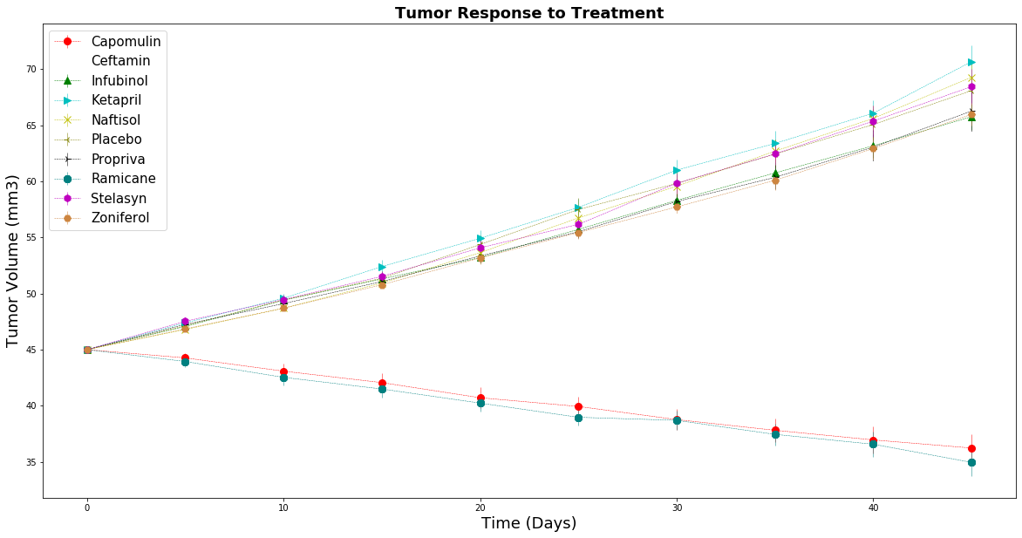

Fig 2. The Tumor response to the four drugs requested

As it can be observed from Fig. 1 and Fig. 2, two Tumor response to two drugs (Capomulin and Ramicane) has been positive and by consuming these two drugs the volume of Tumor has reduced. Among these two drugs Capomulin is the one which is among the four requested drugs so among all drugs in focus Capomulin is working well on Tumor treatment.

Fig 3. Metastatic response to all drugs studied

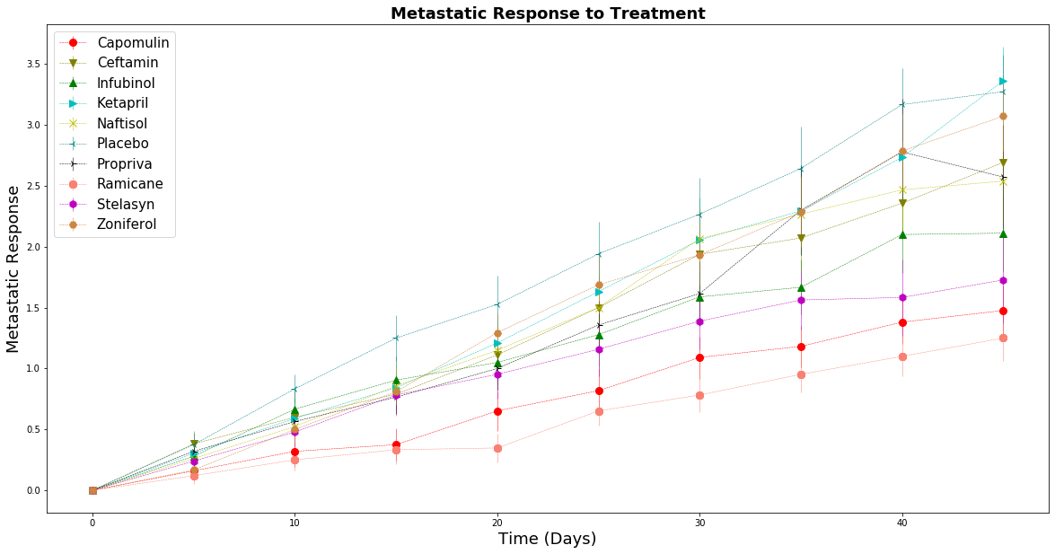

Fig 4. Metastatic response to four drugs requested

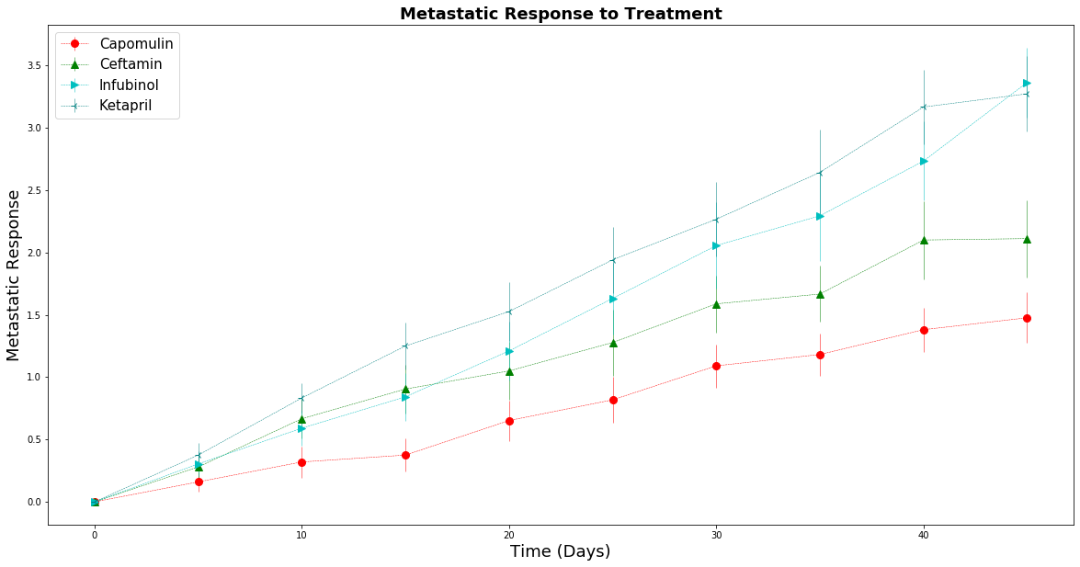

As it can be observed in Fig. 3 and Fig. 4, the Metastatic response to two successful drugs (Capomulin and Ramicane) are the best, which means the tumor spread when consuming these drugs has been slowest. Among the requested four drugs, Capomulin has been the drug with the best metastatic response.

Fig 5. Survival rates for all ten drugs

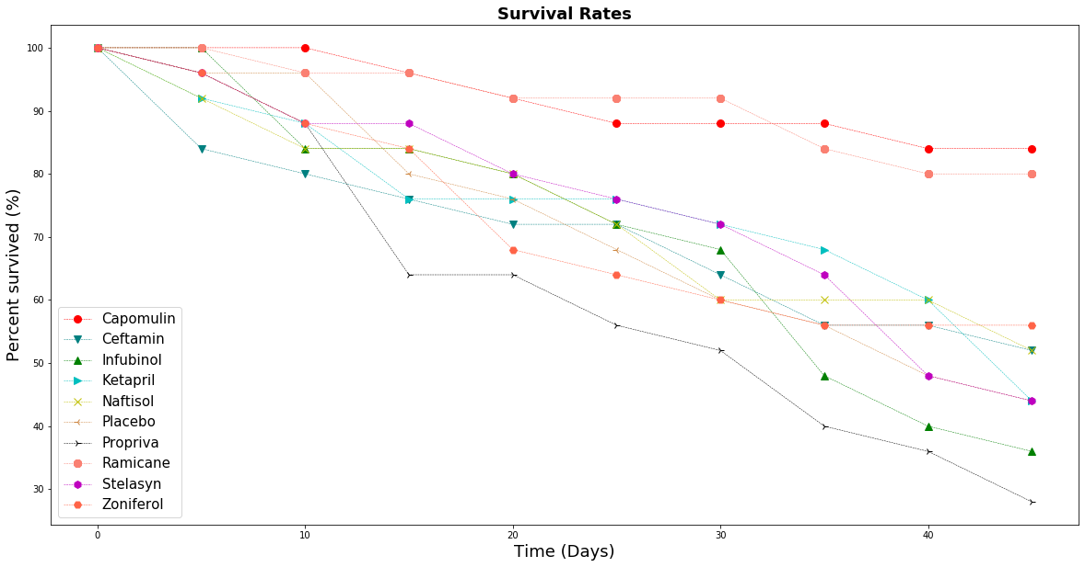

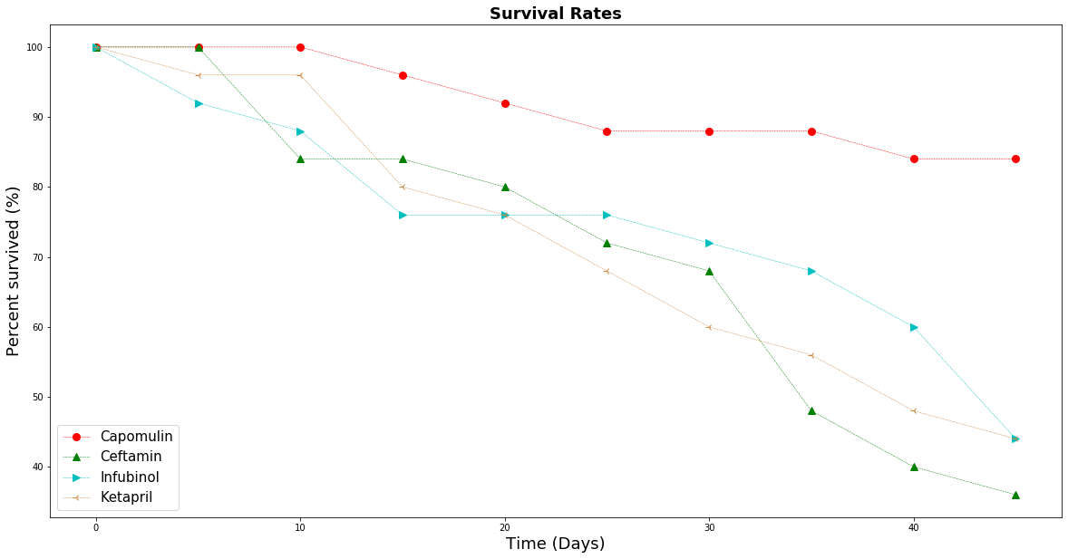Fig 6. Survival rates for four drugs requested

As it can be observed in Fig. 5 and Fig. 6 the survival rate for the mice when consuming (Capomulin and Ramicane) is the best. Again, Capomulin among four requested drugs has the best survival rate.

Fig 7. Tumor Change over time for all ten drugs

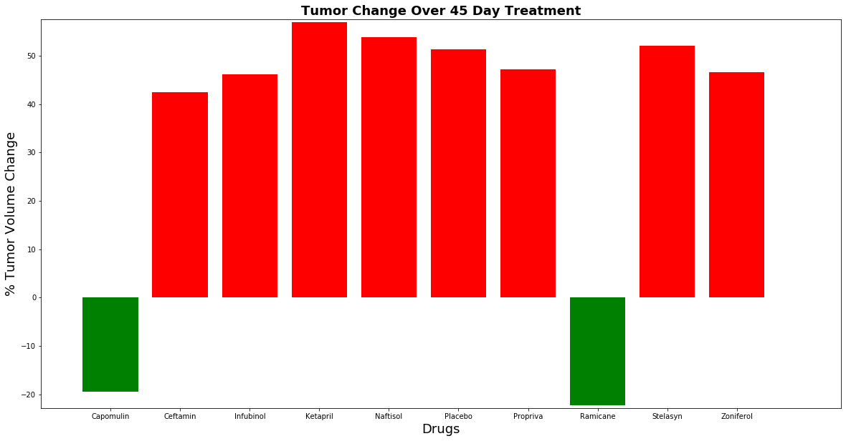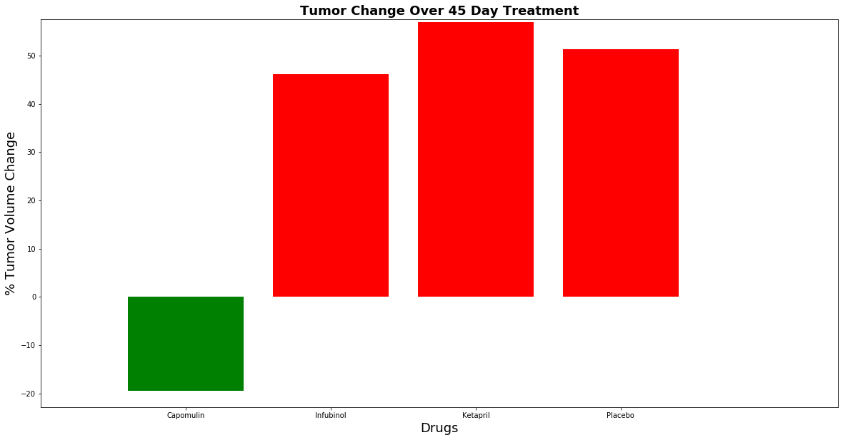 Fig 8. Tumor Change over time for four requested drugs

As we can see in Fig. 7 and Fig. 8 the tumor has continued to increased in size by consuming all drugs except for Capomulin and Ramicane. By consumption of these two drugs the tumor has reduced in size by time. So these two drugs are working on tumor and among the four requested drugs Capomulin is the only one which has a positive impact on the tumor.